**Chinook Data Warehouse – SSIS**

**Team 16: Kaushal Chaudhry, Gauresh Chavan, Mohit Ruke, Rishi Rajani**

1. Create the DW DDL for each database (.sql files included)
2. Create a data model using Toad Data Modeler for one of the DWs (.txp model file included)
3. Create the source-to-target (S2T) maps (.xlsx file include)
4. Create SSIS job(s) to load the following

**Chinook (SQL Server) to Chinook_DW (Oracle)**

**DimArtist**

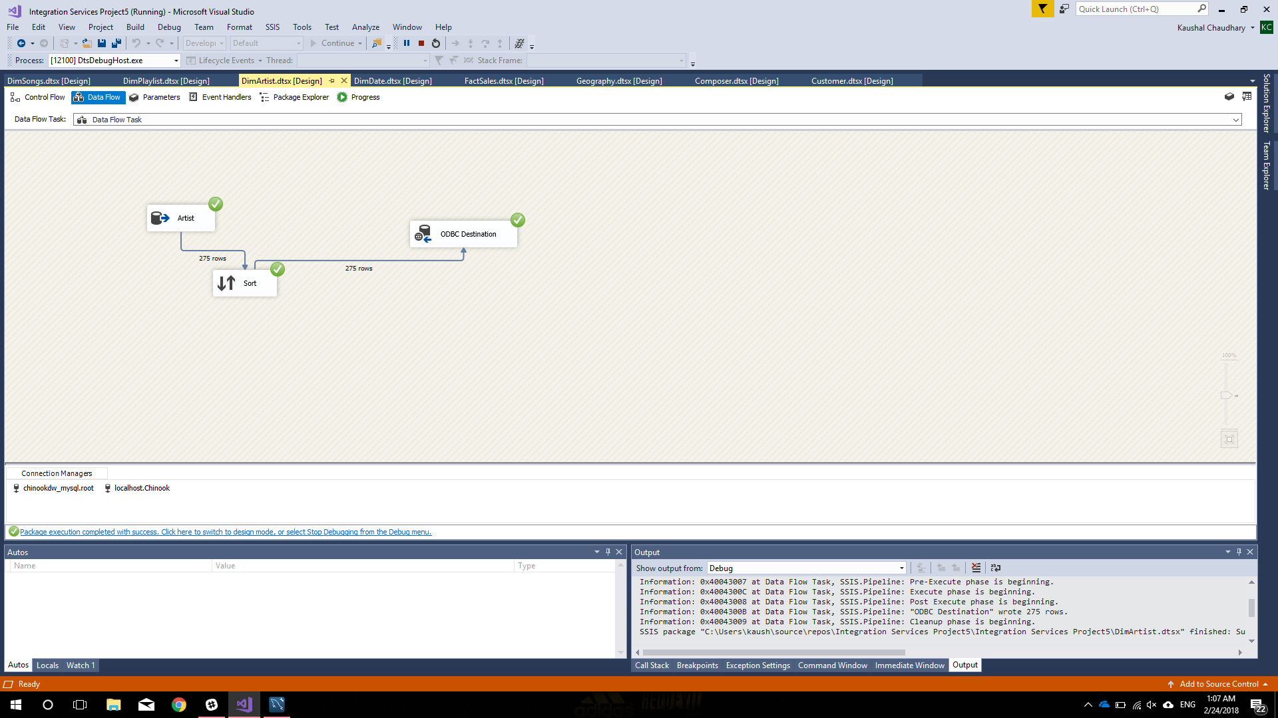

**DimComposer**

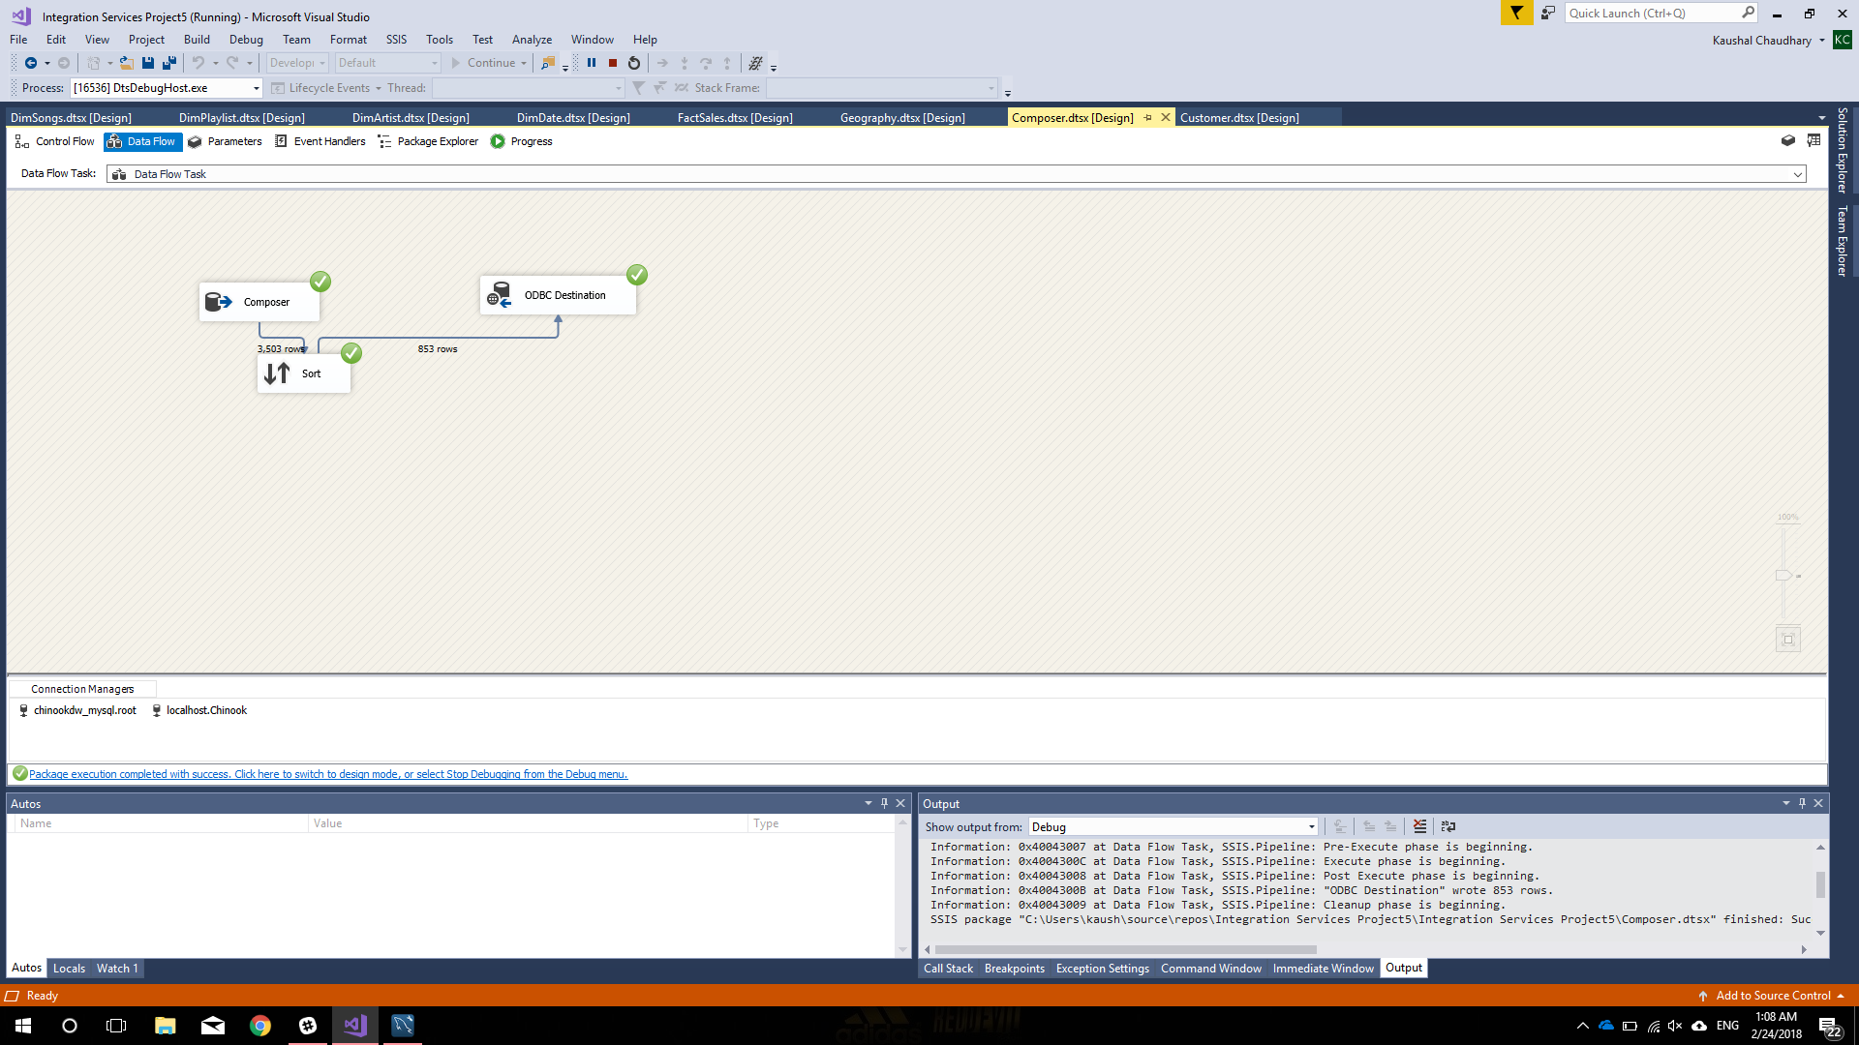

**DimCustomer**

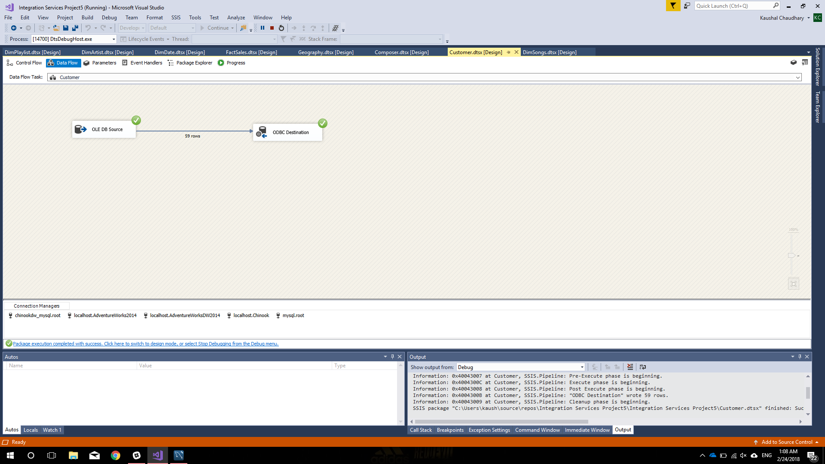

**DimGeogoraphy**

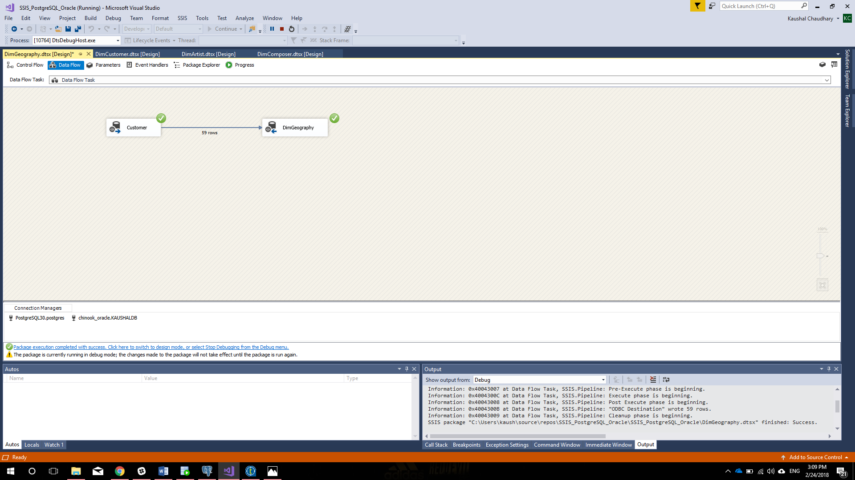

**DimPlaylist**

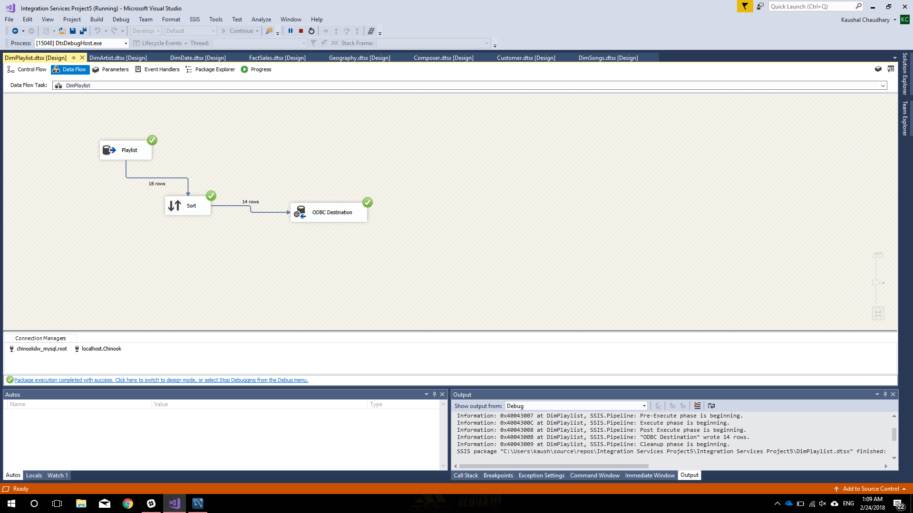

**DimDate**

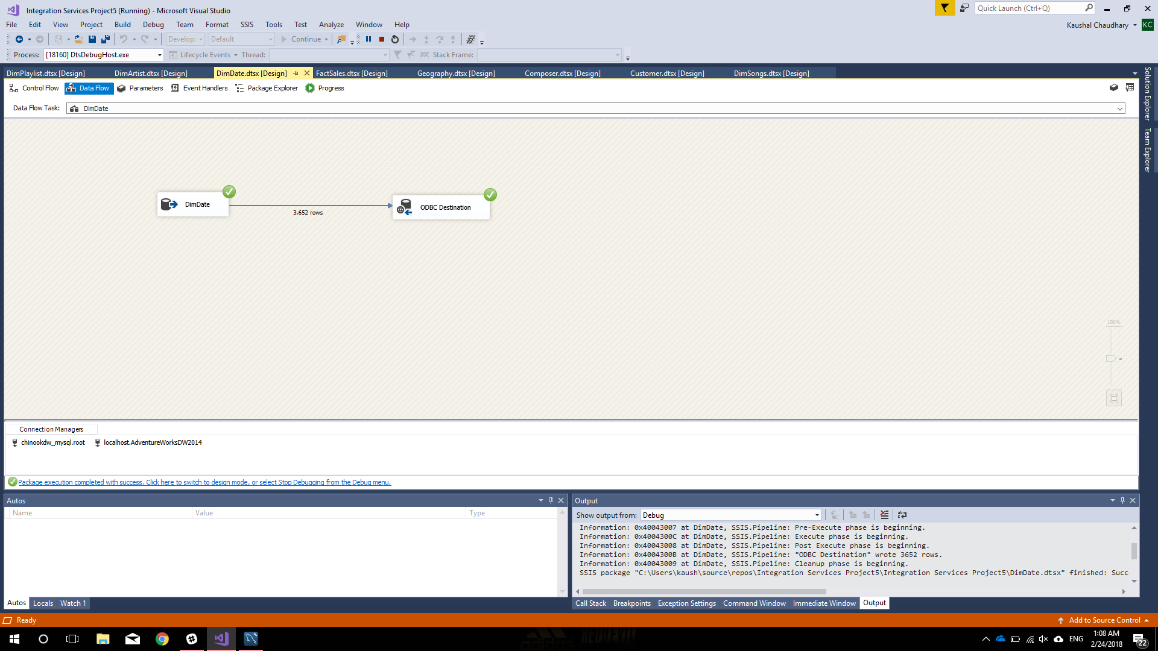

**DimSongs**

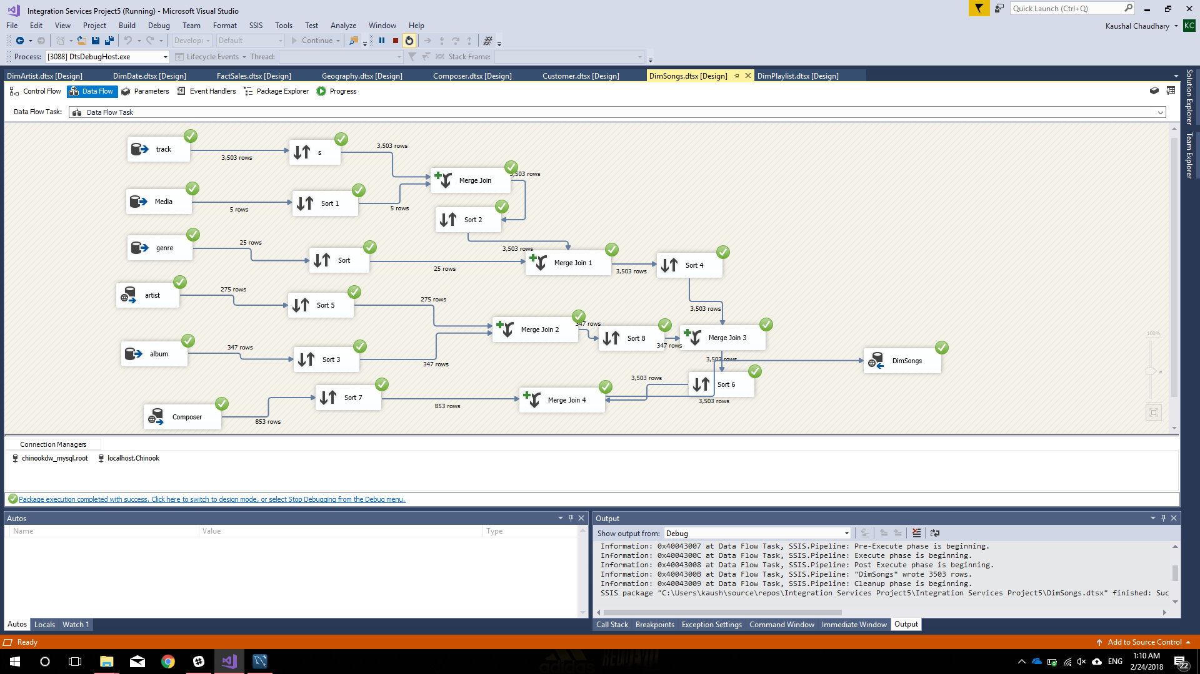

**FactSales**

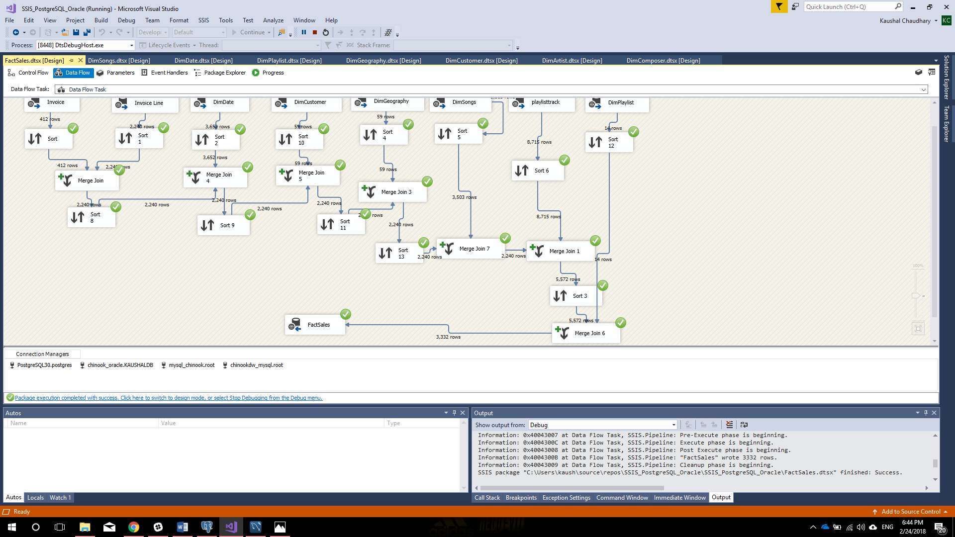

**Chinook (Postgre) to Chinook_DW (MYSQL)**

**DimArtist**

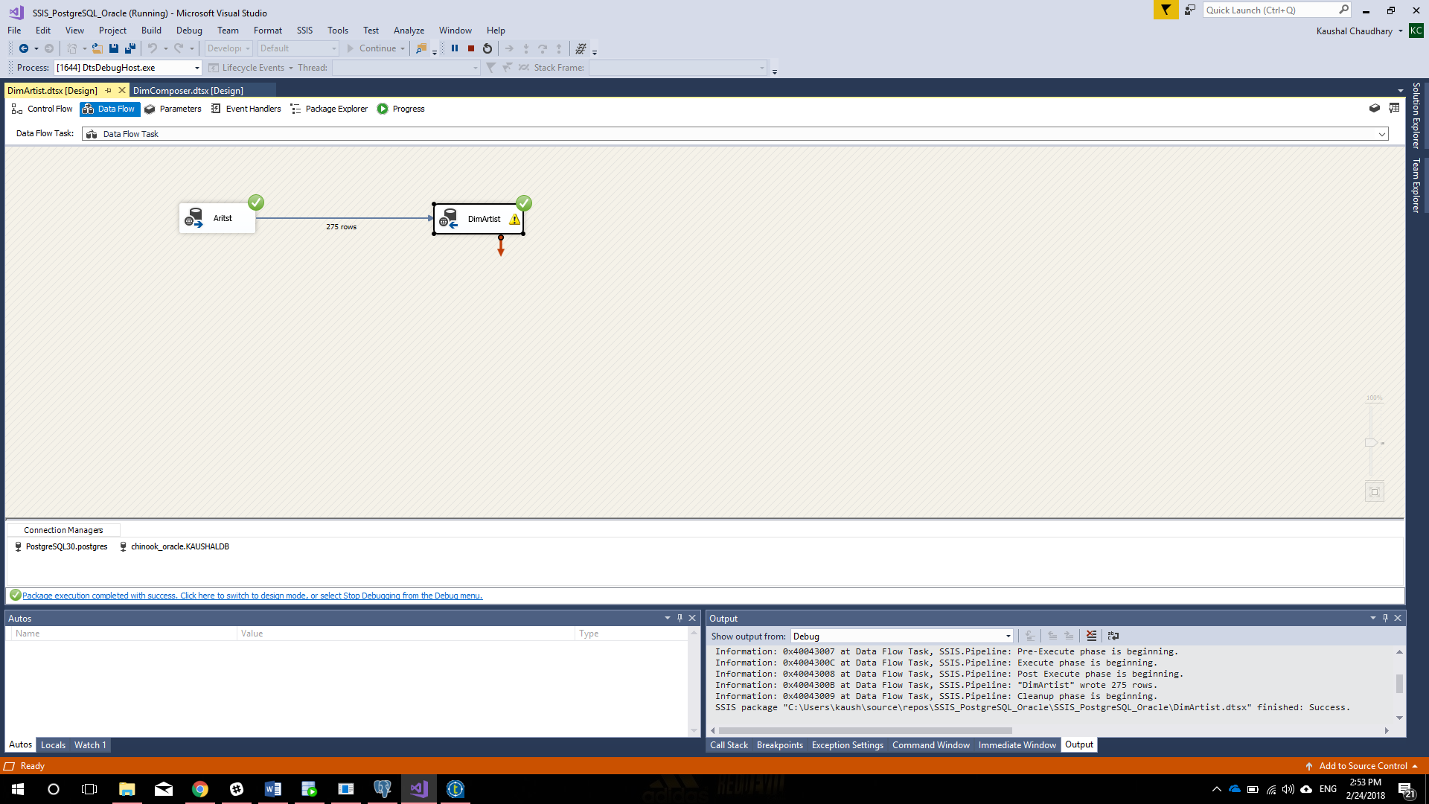

**DimComposer**

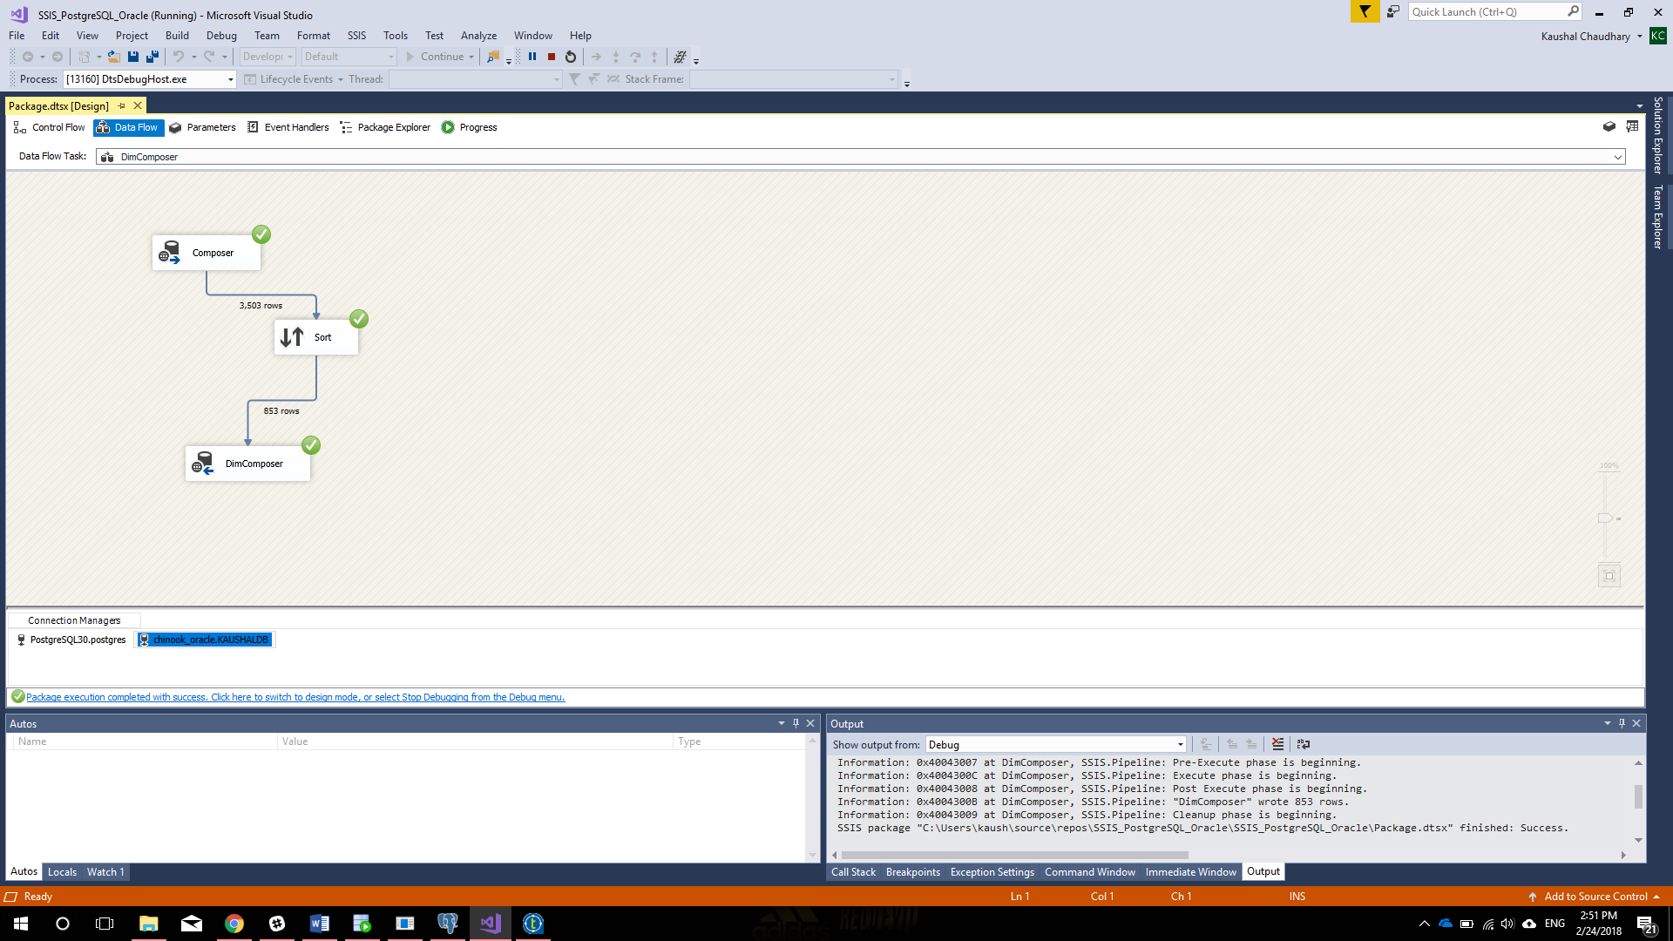

**DimCustomer**

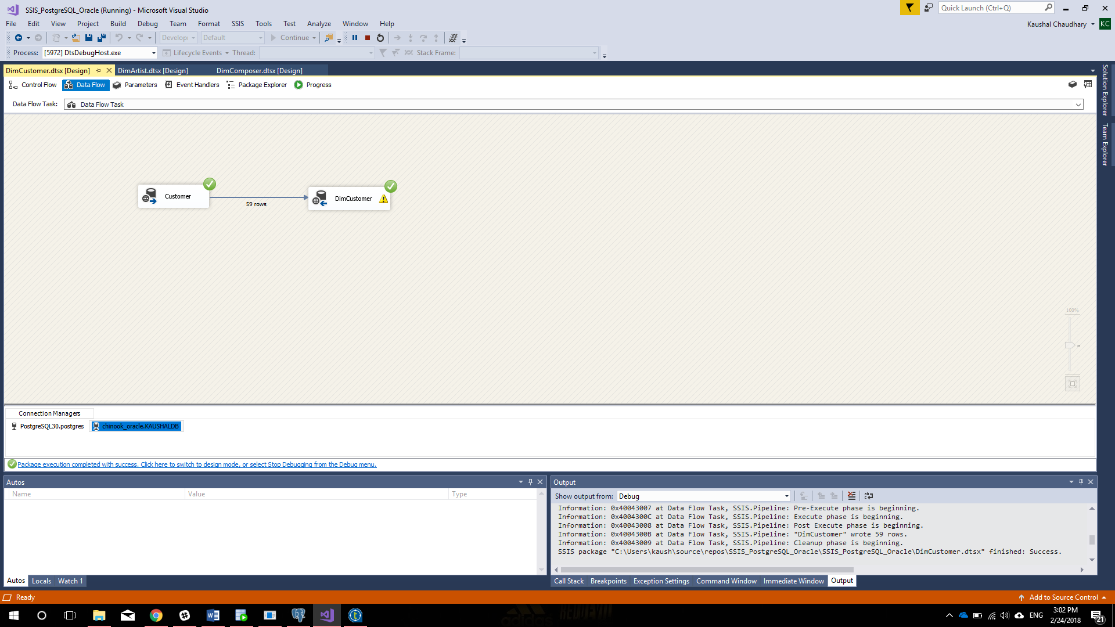

**DimGeogoraphy**



**DimPlaylist**

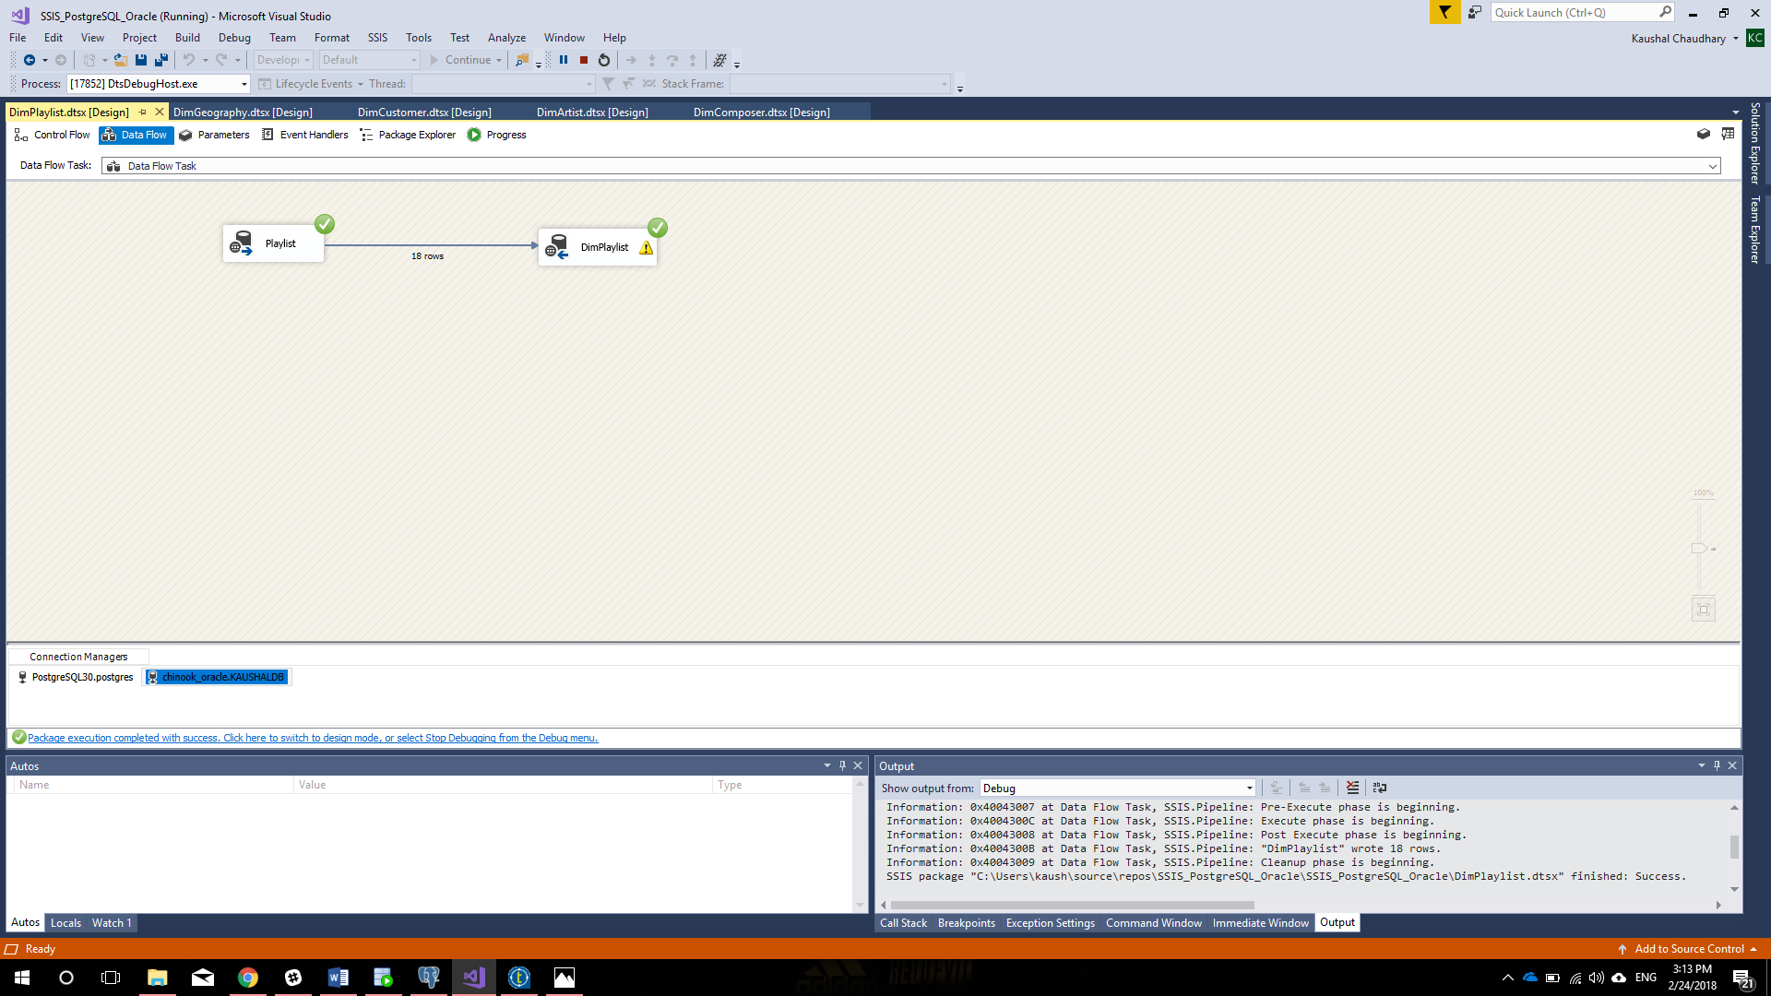

**DimDate**

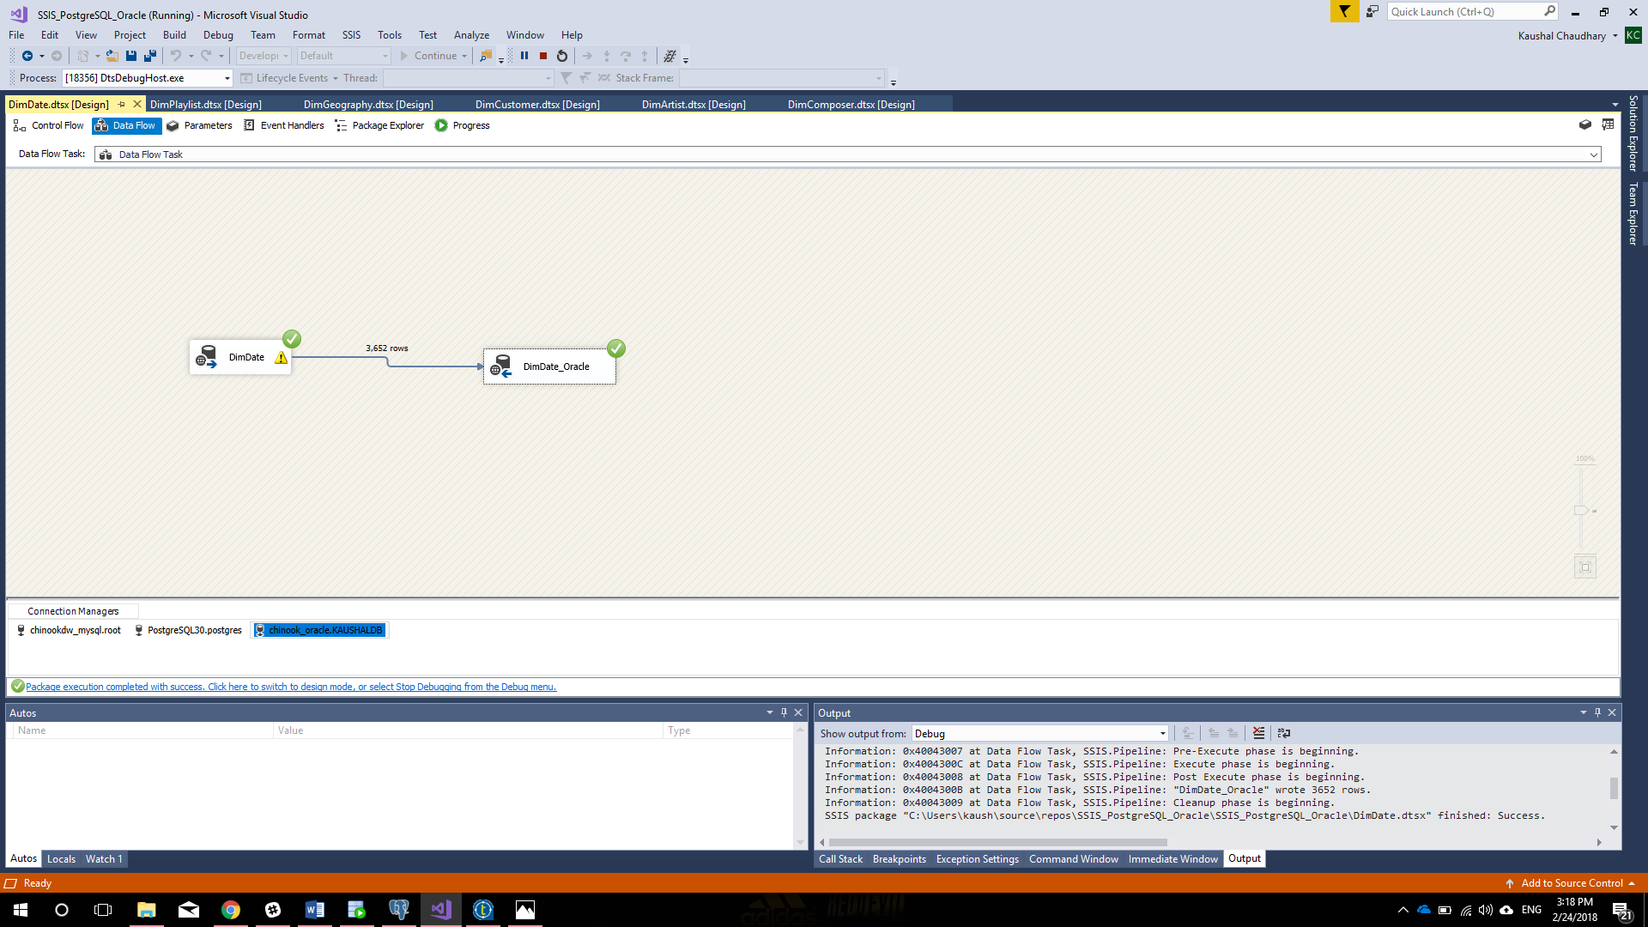

**DimSongs**

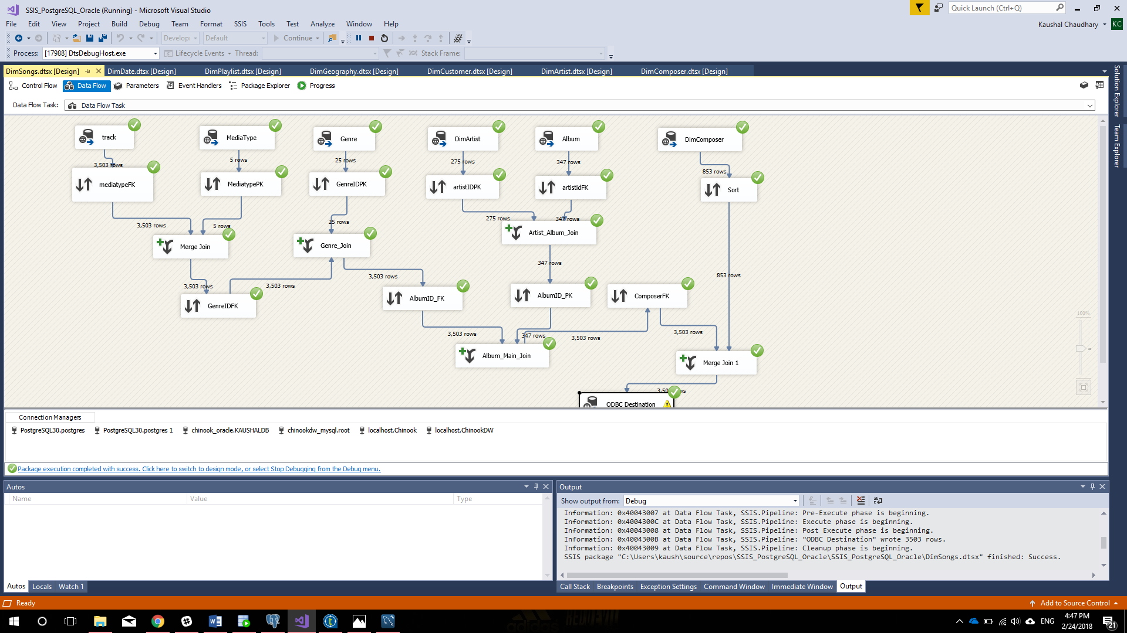

**FactSales**



List the following information for each of the loaded tables in each dbms:  
**SqlServer 🡪 Oracle**

|  |  |  |  |  |
| --- | --- | --- | --- | --- |
| **Table Name** | **Row Count** | **Max(DI_Created_Date)** | **Current_User** | **Current_Timestamp** |
| DimArtist | 275 | 24/02/2018 |  | 24/02/2018 16:14 |
| DimPlaylist | 18 | 24/02/2018 |  | 24/02/2018 16:15 |
| DimCustomer | 59 | 24/02/2018 |  | 24/02/2018 16:16 |
| DimComposer | 852 | 24/02/2018 |  | 24/02/2018 16:16 |
| DimGeography | 59 | 24/02/2018 |  | 24/02/2018 16:16 |
| DimDate | 3652 | 24/02/2018 |  | 24/02/2018 16:16 |
| DimSongs | 3503 | 24/02/2018 |  | 24/02/2018 16:17 |
| FactSales | 412 | 24/02/2018 |  | 24/02/2018 16:21 |

**Postgre 🡪 MySQL**

|  |  |  |  |  |
| --- | --- | --- | --- | --- |
| **Table Name** | **Row Count** | **Max(DI_Created_Date)** | **Current_User** | **Current_Timestamp** |
| DimArtist | 275 | 24/02/2018 |  | 24/02/2018 15:34 |
| DimPlaylist | 18 | 24/02/2018 |  | 24/02/2018 15:35 |
| DimCustomer | 59 | 24/02/2018 |  | 24/02/2018 15:36 |
| DimComposer | 852 | 24/02/2018 |  | 24/02/2018 15:36 |
| DimGeography | 59 | 24/02/2018 |  | 24/02/2018 15:36 |
| DimDate | 3652 | 23/02/2018 |  | 24/02/2018 15:36 |
| DimSongs | 3503 | 24/02/2018 |  | 24/02/2018 15:37 |
| FactSales | 412 | 24/02/2018 |  | 24/02/2018 15:41 |

1. Create the Table documentation for each of the jobs used to complete this assignment & save as a zip file
2. List following information for each of the final SSIS jobs you ran to load the tables in each dbms:  
   **SQL Server 🡪 Oracle**Time to complete the Root Job (milliseconds): 1256  
   Time it was completed: 24/02/2018 16:21

**Postgre 🡪 MySQL** Time to complete the Root Job (milliseconds): 1355  
 Time it was completed: 24/02/2018 15:41

1. List the total time to load each of the DWs (milliseconds):   
   **SQL Server 🡪 Oracle**  
   Total time: 11560

**Postgre 🡪 MySQL** Total time: 12551